Rangi’s Hangi

*/ Untitled Group Name /*

Table of Contents

**Vision Statement** **2**

**Mission Statement** **2**

**Who is your Target Audience?** **2**

**What are some inspirations?** **2**

**What are some competitors to your game?** **3**

**What will your game do different from them?** **3**

**What format are you shooting for?** **3**

**What & Who are you designing with?** **3**

**How will you market your game?** **3**

**What is your budget?** **3**

**Features & Concepts** **3**

**Taught Mechanics** **4**

**Untaught Mechanics** **4**

**Game Flow** **4**

**Describe the 3 C’s (character, control, camera)** **4**

**Level & World Design** **4**

**Narrative & Quest Design** **4**

**Combat & Enemy Design** **4**

**Art Direction** **5**

**Menu Design** **5**

**UI Design** **5**

**Animation Design** **5**

**VFX Design** **5**

**Art Asset Breakdown** **5**

**Sound Direction** **5**

**Sound Design** **6**

**Music Design** **6**

**Sound Asset Breakdown** **6**

**High Level Milestone Schedule** **6**

# **Vision Statement**

Rangi’s Hangi is an educational mobile game deidcated to teaching young people about the Maori language. The story is about Rangi trying to make the best Hangi available that will please the people who come to enjoy the hangi.

The game will be a 2D drag and drop mobile game on Android devices where the player must drag the correct ingredients which will be written in Maori into the hangi pit. As the levels get harder the people attending the hangi will start requesting specific items that the player must put into the pit to pass the level.

# **Mission Statement**

Rangi’s Hangi aims to be an educational game for all ages that will help teach Maori vocabulary while providing enjoyment for the player. The game will be a pick up and play with minimum teaching involved.

# **Who is your Target Audience?**

Rangi’s Hangi is targeted at children to teenages bewteen the ages of 8 – 16 who are currently learning Maori in school or who have an intrest for the language.

Anyone who is able to read english and work a mobile phone app can play our game.

# **What are some inspirations?**

Cartoonish, 2D mobile games which appeal to the younger audience such as Hunt Cook, Angry Birds and Kingdom Rush.

Bright and cheerful colours such as Zelda Wind Waker, Clash of clans, Candy Crush, Hat in Time and Plants vs Zombies.

# **What are some competitors to your game?**

Our main compeittiors are other educational Maori Games developed in NZ. Many of them are not game based and are often for adults. But there are a few such as:

The “Kura App” Developed by the Victoria University of Education. The app was developed by lecturer Tabitha McKenzie and has a competitive feature as well as free to download.

Te Pumanawa – Lean Maori Language app. Basic leaning Maori app developed for adults more than children. Simple interface that won’t really appeal to children.

Papapapa- Te reo Maori App for tamariki (children). Its an app developed for children under 5 and sponsered by the Maori television company. Requires caregiver to help most of it.

# **What will your game do different from them?**

Rangi’s Hangi aims to teach younger children about words in Maori. Our app will not fully teach them about everything there is know about the languge but rather create an intrest in the children so that they will be more inclined to go find out more about the language themselves.

Since many apps made are either tackling the language problem at an adult age or

# **What format are you shooting for?**

Android mobiles.

Might do Apple if the time allows it.

Game will be created in Unity.

# **What & Who are you designing with?**

Rangi’s Hangi is being developed by Media design school graduates consisting of a three person team. Members broken down into three Programmers and three Artist.

Programmers:

Brian Wong

Artist:

Larissa Dong

Rangi Christie

# **How will you market your game?**

Given this is projects made by students to help boost their portfolio there is no budget to do any paid marketing of the game with no plans to set aside any kind of a budget to do paid for marketing, however; we be using social media in attempt to boost the game online profile.

Twitter will be used by the team to post small but regular updates on the game, giving people a kind of behind the scenes look at the game and its development. When the game is complete it will be put on the Play store after buying a licence for it.

Word of mouth will be used for friends and family and hope that it will spread.

# **What is your budget?**

Currently no budget as this will be a quick game made quickly but we will try and apply for grants.

# **Features & Concepts**

Drag and Drop – drag and drop food into the pit. This is a very easy motion that alot of children know how to do now.

Pick up and Play – Simple and easy to play with a very short tutorial. The player should be able to finish all the levels just by dragging the right words into the pit but the game will reward players for getting it more accurate.

Educational Aspect – teaching children about the Maori language – our main selling point.

Free to play – Our game is an educational game so we cannot charge people for it espically since its made for kids. If we can it would be nice to get some revenue through ads.

Levels – levels will get harder and the volcabulary will get harder as the player progresses.

**Taught Mechanics**

Maori Volcabulary – The main aim of the game is education. Teaching words to kids through memory and rewarding them when they get it right.

Drag and Drop – Drag and drop words into the pit. This will be taught in the tutorial.

# **Untaught Mechanics**

In level progression - Levels will be largely linear in design, where players will be required to move from the start point to the end point of a level. This is a very familiar style of level progression that almost all of the gaming community has experienced at some stage therefore there is no need to teach the player.

Level selection - Level selection will be conducted within an isolated menu. Both accessible and inaccessible options on the menu will be clear to the player. This is a very familiar style of level selection that almost all of the gaming community has experienced at some stage therefore there is no need to teach the player.

# **Game Flow**

*Describe the game flow. This includes menus, progression etc.*

Typical game flow will see the player move between the map menu and levels.

The player will have to make a hangi by dragging the right items into the pit.

This game will use a linear level progression system, where new levels will will become accessible as previous levels are completed.

As the new levels are unlocked the the hangi will get harder and harder to make. If the player doesn’t complete the level they will not be able to finish it.

# **Describe the 3 C’s (character, control, camera)**

**Character:** The character will be a simple character called Rangi that will just stand on the side of the screen and tell the player whats going on through dialouge. The character will have animations that will give more game juice.

**Control:**

Touch pad where the player can select and drag and drop whats needed.

**Camera:**

2D side view of of the whole level and scene.

# **Level & World Design**

The game is set in New Zealand at a hangi managed by Rangi who is a chef in training. Rangi just wants to make the best hangi and hopes that his customers have a good time by placing the right ingredients so that everyone can have something they want to eat.

# **Narrative & Quest Design**

The main character is a man named Rangi who is training to be a chef and has his own 24/7 Hangi pit that is very popular with tourists. The player will have to help Rangi drag Maori words into the hangi pit and hope they are right. As the level progresses the customers will start requesting specific items such as “no meat” or “extra Chicken” and each request that is meet will give the player extra points.

# **Combat & Enemy Design**

Enemies will be the customers who come to Rangi’s hangi. They will be the main obstacle for the player because if they are not pleased the player will not be able to complete the level and move on.

There are no real combat in the game as it will be a realaxing and educational game.

# **Art Direction**

Hogei is a game made for a wide audience including small children. We are going for a cartoony style. Simple, bold and quirky style with a few hard edges. The main consideration when designing sets and characters for our game is our top down camera angle. The angle of the camera will not change throughout the game so everything should fit accordingly.

The art direction of the game draws inspirations from classic games such as Conker: Bad fur day and Psychonauts. These two games were selected for their weird, unique and quirky style to their art design process. We wanted to create a game where the team’s strength is highly showcased and as a collaborate whole we knew it had to be in a stylized art form. We knew from the beginning of development that creating a stylized game involved a lot of heavy hand painted textures. This process would be time consuming therefore planning of assets creation and design sketches had to be done. What made these game’s unique is also their selection and choice of color pallete. We had to breakdown a lot of these game’s color schemes to see how light and shadow are made as we had a lot of issues with our game becoming to linear towards a certain color. Shapes and Form with their assets are also deeply analyzed to make sure our game looks and feel like it is in suit towards the stylized theme.

# **Menu Design**

The game is set in a world where there are no continents, only giant flying animals. Inhabitants of this world all live on these giant flying animals and the surrounding floating islands. Each level of the game will take place on one of these flying animals. While this was our original idea it has changed to islands surrounding the giant creatures populated by smaller creatures. We wanted a map similar to that of overcooked or kingdom rush. We want a diegetic map that the player can interact with and that the player can move around and navigate.

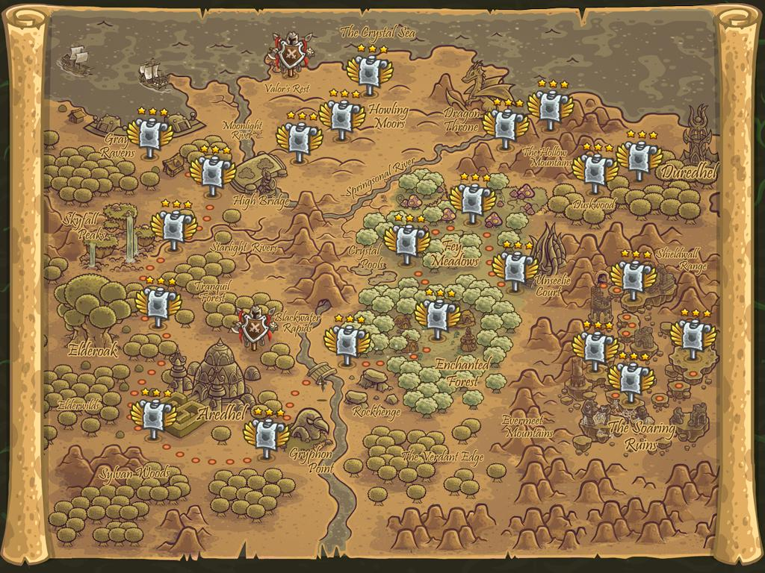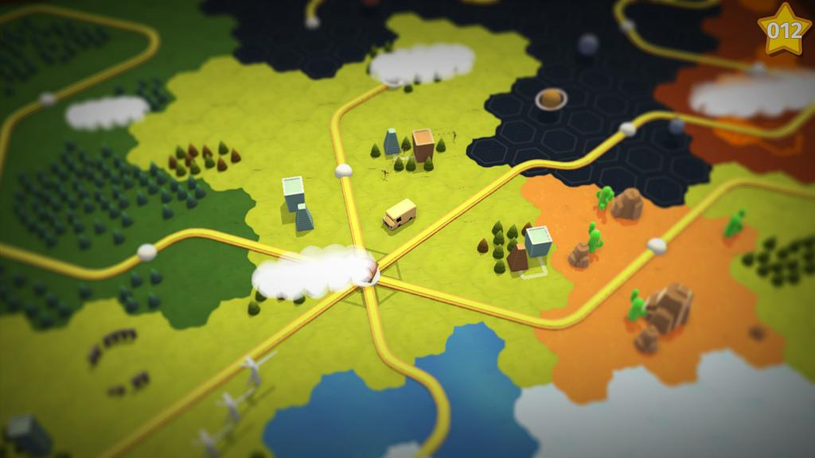

Original menu was a hub town where the player would be able to walk around and head to the top of the city where there is a giant soup pot where the player is able to put ingredients into the pot from the enemies that they kill giving a boost to the player. The hot pot was located at the blowhole of the flying whale that the player is riding upon. The idea was scrapped as making the town was a bit large and not being able to populate it with any npc, models or buildings made it pretty barren for the player to walk around. It was unintresting and was later scrapped for a smaller menu and hot pot.

Main menu and level select will be combined into one as we want a diegetic menu. The menu is now a giant scroll that the player can select one of the floating islands to play. There will be a button that the player can click to access the hot pot in which they will be able to change weapons and the bullets they want to take into the game as well as make soup that will give them boosts for the next level. The player will unlock levels everytime they finish a level to where they will have to fight a final boss at the end.

The hot pot is one of the main aspects of the game as it is the players main inventory where they can change their weapons, bullets and create power up for the player to use in the game. We want the player to be able to choose ingredients from the enemies that they have killed to either help boost the player or boost the weapon that they have. We know that we had to implement a hot pot as the main point of upgrading the player.

Implementing the hot pot was hard as for a very long time we didn't know where to place it. The original idea of having a hub city was scrapped as it was too big and unintresting and we eventually put it together with the level selection.

# **UI Design**

*Describe level and world design approach and implementation.*

The game did need a lot of UI including

* Player Health Bar
* Boss Health Bar
* Miniboss Health Bar
* Hot Pot
* Title Screen Buttons
* Instruction Pages
* Credits
* Game Over Buttons
* Weapon Wheel
* Icon
* Cursor/Crosshair

A Lot of our buttons in the hot pot and the game over screen we wanted to go with a simple theme so they all look the same. We wanted to kind of show off the pirate theme we were going for. The rugged, seafaring but still quirky style so we went with hand painted, cracked wood style. Making all the buttons similar brings the theme together.

We needed instructions panels,credits and other pages to explain to the player what they needed to do. If there is time we would like a tutorial level with pauses in between to explain to the player what they needed to do.

A weapon wheel for the player is needed for the player to change weapons. Something simple and quirky for that is simple enough. It doesn't need to be extravagant due to the limited number of weapons we are able to create.

Health Bar is super important for our game as its all about surviving and the player should be able to tell how much health they have left just by looking at the health bar. We needed a player, boss and mini boss health bar. For the player we wanted a quirky health bar and looked to zelda and a lot of mobile game UI as they are very eye catching.

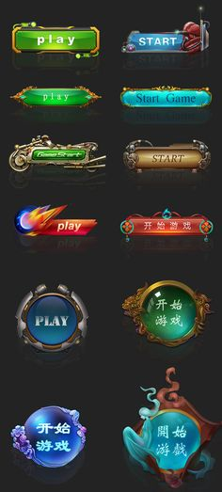

This is our final design for the player health bar.

We even made Unique health bars for the boss and mini boss enemies.

# **Animation Design**

*Describe level and world design approach and implementation.*

Due to the nature of the game all the animation must be super cartoonish and exaggerated because its top down view. Using @kekeflipnote animations as our main reference we made very bouncy animations for our enemies.

Animations are to illustrate the character and movements of the model.

* Character needs movement (if applicable), Idle, Attack, and on hit animation. Depending on character, it may also need a detection animation. Each animation have to loop smoothly and appropriately
* Animation should consider the character’s personality and game mechanics, i.e type of attack.
* We used secondary actions will help add character.
* Movement animation should be timed to suit distance travelled.
* Exaggerate animation to strengthen character personality.
* We Use the 12 principles of animation effectively.
* Above pictures illustrates an exaggeration of a Ram standing on hindlegs, upon detection. Its front legs move as it readies for attack. This animation is very fitting for a Ram’s personality.

* Above pictures illustrates Anticipation, right before the attack; squash. Then the actual attack; stretch. Demonstrating a great use of animation principle.

* Pictures above illustrates character appropriate animation, of our chicken coop mini boss
* Secondary movements of beak and tail adds to the coop’s chicken like behaviours.

# **VFX Design**

The bullets created for the game are all mesh based. Therefore the designs for the visual effects have to be created with shaders. With minimal experience with shaders, we had to turn to node-based shaders in Unity by using Amplify Shader. This resulted in the creation of a outline shader. The outline shader will be used in all the bullets used in the game, from the main character to the enemies. As this game is a mixture of a bullet-hell game, bullets have to be visually striking in order to be able to dodge and avoid them.

The player’s bullet must feel powerful therefore a trail vfx is added with a glowing yellow neon color to showcase the power of the weapon.

# 

The enemies however have two types of bullets. One trailess and the other with trails. Just to give them some variations and not have them appear constantly all the time. What makes them different from the player is that the bullets are the ones glowing this time. The trail is the secondary vfx and therefore has to be less visually striking than the bullet itself.

Hit effects are made with white sprites just to have some visual contrast against the high saturated colors of the scenes.

# 

Apart from the bullets, other vfx were needed to create atmosphere and depth to the level designs. A fire vfx was added to create burning coops for the mini boss arena. This little detail adds up to create a more intensified scene and immerse the player. The fire vfx was also added to the bottom of the hotpot.

# 

Other subtle effects are created to show an indication of progression. I.e grabbing health potions and vfx appear floating above you. Or when you press the cook button to complete the hotpot and you see it cooking with the use of glowing vfx.

# **Lighting**

The main consideration for our lighting is the reflected light colour. We needed to break the yellowish hue of our floating island and assets. So we used a purple light to contrast the yellow.

For the boss level we wanted to create a different atmosphere. So we decided on a darker lighting, not to depict night time but to create a dark stormy gloomy atmosphere.

# **Art Asset Breakdown**

The assets created have to be stylized. When we say ‘stylized’ we don’t mean symmetrical; forms should be in some shape or form be distorted and warped. The stylized art from is the opposite of realism, as real-life items are viewed/perceived to be more in a unique/quirky way but essentially still be close to, or familiar to that original concept. Shape, silhouette and form is taken to careful consideration to suit our top down game. We are making a fast paced game, so readability is very important, hence our designs have gone through plenty of iterations to make sure they are unique and distinct to the players.

The art process goes from preliminary pen to paper sketches, where all the artist have to approve of the drawings before it is created into to 3d assets.To make sure we create a immersive and believable world, we stay well communicated to make sure our assets are compatible and the style to stay consistent . We often trade screenshots of our work to get a second opinion. Furthermore, with Allen being our strongest texture artist, he did a large portion of the texturing, providing a great style guide and colour palette for the Game.

Those 3d assets will go through breakdowns and iterations till the team is satisfied with the final results. All assets goes through the approval of all artists.

For example, this is the process of the making of our ram:

* We start with a concept with strong silhouette
* As seen below, the ram (on the right) was replaced due to a weak silhouette.

* Different horns are made for readability comparison
* The one on the right was chosen for its outwardly pointed Orientation

Once approved, it is uved and sent over to be hand painted in Photoshop and Blender. In Unity every assets has a material attached to it, containing two files. One diffuse (color map) and one AO (ambient occlusion) map. The ambient occlusion created is a combination of 3 different maps (AO, curvature, object normals) in order to bake a fake top down lighting.

Once in Unity, we design creative and interesting level design with the assets. When the level design feels good, we then tweak the scale and rotation models to create aesthetic scenes and an immersive world.

We then test play and evaluate the level, and decide if we need to change or make more assets to perfect the scene. One of the major issues we had with our assets is that everything was yellow, we needed other colours to make our world seem less dessert like.